Practical 1
Field | Details
Name of Student | Mohammed Danish Firoz Shaikh
Roll No. of Student | 329
Semester | B.Sc (I.T) SEM-V
Academic Year | 2026-2027
Subject | Data Visualization with Power BI and Tableau
Faculty In-charge | Mr. Shahid Ansari
Practical No. | 1
Title | Getting Started with Tableau and Building Basic Visualizations  - Connect to a CSV dataset and explore the Tableau interface  - Identify and differentiate Measures and Dimensions  - Convert fields between discrete and continuous and observe changes  - Create and customize a basic bar chart  - Build a line chart for time-series analysis  - Create a geographic map visualization  - Combine multiple charts into a simple interactive dashboard
Date

What is Tableau?
- Tableau is a Business Intelligence (BI) and Data Visualization tool used to analyze data and create interactive charts, graphs, maps, and dashboards without requiring much programming knowledge.
In simple words:
- Tableau converts raw data into meaningful and interactive visualizations that help us understand patterns, trends, and insights.

Example
Suppose a supermarket has the following sales data:
Product | Sales
Laptop | 80,000
Mobile | 50,000
Printer | 30,000
Tablet | 40,000
Instead of looking at numbers like this:
Laptop = 80,000
Mobile = 50,000
Printer = 30,000
Tablet = 40,000
Tableau can display it as a Bar Chart:
Sales
80000 | ██████
70000 |
60000 |
50000 | █████
40000 | ████
30000 | ███
20000 |
--------------------------------
Laptop Mobile Tablet Printer
This makes it much easier to:
- Compare values
- Identify trends
- Analyze large datasets
- Make business decisions

Why Do We Use Tableau?
- Data Analysis
- Data Visualization
- Creating Dashboards
- Generating Reports
- Business Intelligence
- Predictive Analysis
- Sharing insights with others

Features of Tableau
- Drag-and-Drop Interface
- Interactive Dashboards
- Real-Time Data Analysis
- Multiple Data Source Support
- Geographic Maps
- Data Filtering and Sorting
- Trend Analysis
- Easy Report Generation

Data Sources Supported
Tableau can connect to:
- Excel Files
- CSV Files
- Text Files
- SQL Databases
- MySQL
- PostgreSQL
- Microsoft SQL Server
- Oracle
- Google Sheets
- Cloud Services and APIs

Common Charts in Tableau
- Bar Chart
- Line Chart
- Pie Chart
- Scatter Plot
- Histogram
- Heat Map
- Tree Map
- Geographic Map
- Area Chart
- Bubble Chart
- Dashboard
Applications of Tableau
- Sales Analysis
- Financial Reporting
- Healthcare Analytics
- Educational Data Analysis
- Customer Analysis
- Marketing Analytics
- Human Resource Analytics
- Supply Chain Management

Link to download software and dataset
https://drive.google.com/drive/folders/19BkTpVDZeQMi1qwFXL7KZ7SklR4Ev0Zj?usp=sharing
a) Connect to a CSV Dataset and Explore the Tableau Interface
Steps
- Open Tableau.
- Click Text File under Connect.
- Select the Sample Superstore.csv file.
- Click Open.
- Tableau will display the Data Source page.
- Click Sheet 1 to begin visualization.
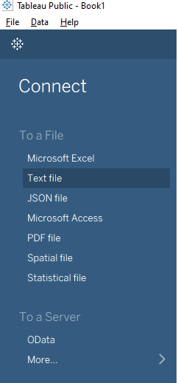
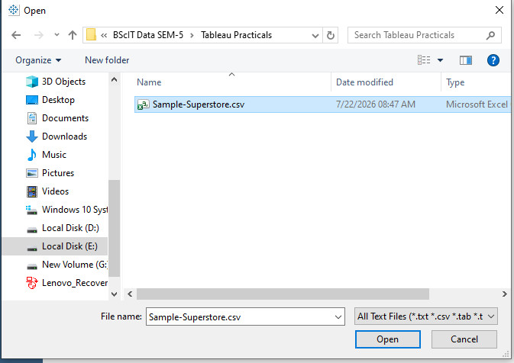
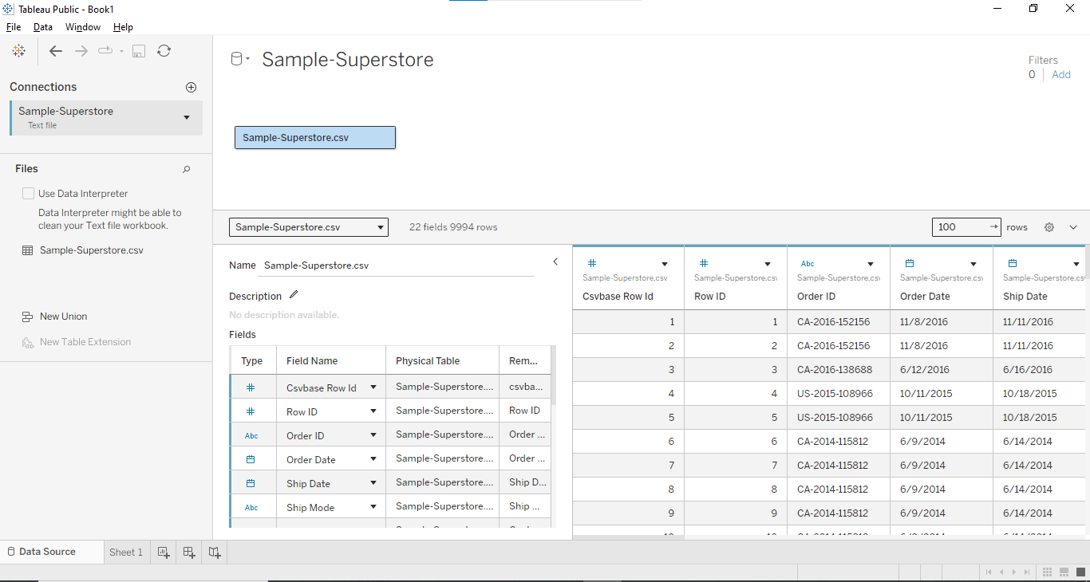
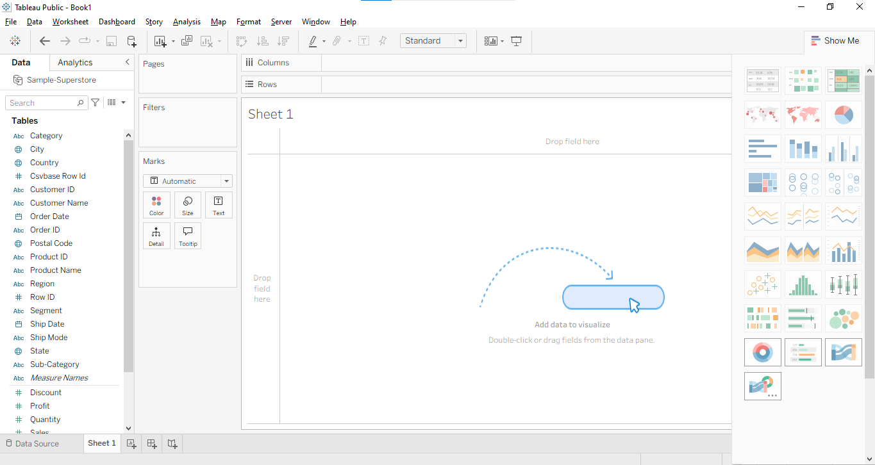
Tableau Interface
Component | Description
Data Pane | Contains Dimensions and Measures
Columns Shelf | Displays horizontal axis
Rows Shelf | Displays vertical axis
Marks Card | Controls Color, Size, Label, Filters etc.
Show Me | Suggests suitable charts
Sheets | Used for creating visualizations
Dashboard | Combines multiple sheets
Story | Creates presentation style reports

b) Identify and Differentiate Measures and Dimensions
Dimensions
These contain categorical values.
Examples:
- Category
- Customer Name
- State
- Region
- Segment
- Ship Mode
Measures
These contain numerical values.
Examples:
- Sales
- Profit
- Quantity
- Discount
Dimension | Measure
Category | Sales
State | Profit
Segment | Quantity
Region | Discount
Dimensions are generally represented in blue color while Measures are represented in green color.

c) Convert Fields Between Discrete and Continuous
Discrete
Produces Headers.
Examples:
- Category
- State
- Region
Continuous
Produces Axes.
Examples:
- Sales
- Profit
- Quantity
Steps
- Drag Sales to Columns.
- Right click Sales.
- Select:
  - Convert to Dimension
  - Convert to Measure
  - Continuous
  - Discrete

Observation
Continuous | Discrete
Creates Axis | Creates Headers
Green Color | Blue Color
Suitable for graphs | Suitable for categories

d) Create and Customize a Basic Bar Chart
Steps
- Drag Category to Columns.
- Drag Sales to Rows.
- Tableau automatically creates a Bar Chart.
- Click Show Me → Bar Chart (optional).
Customization
- Change colors.
- Show labels.
- Sort values.
- Increase bar size.
- Apply filters.

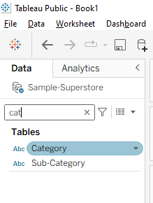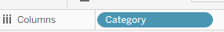
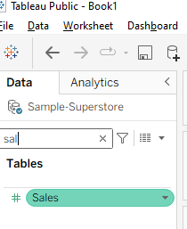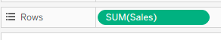
Default bar chart
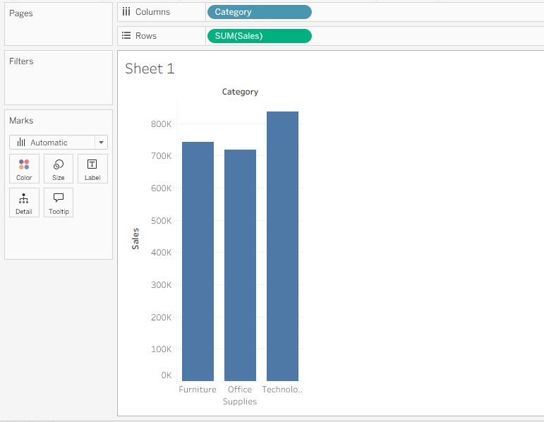
Change color
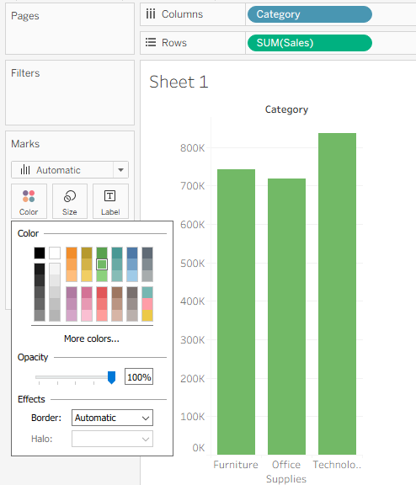
Size
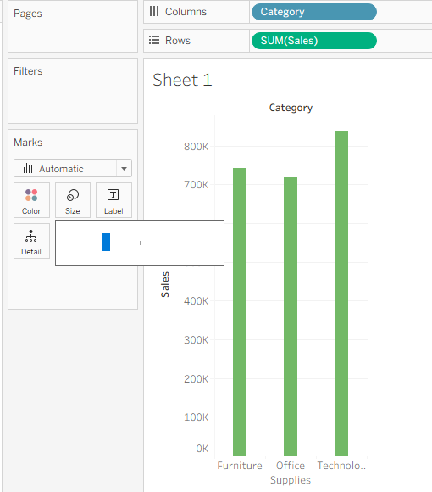
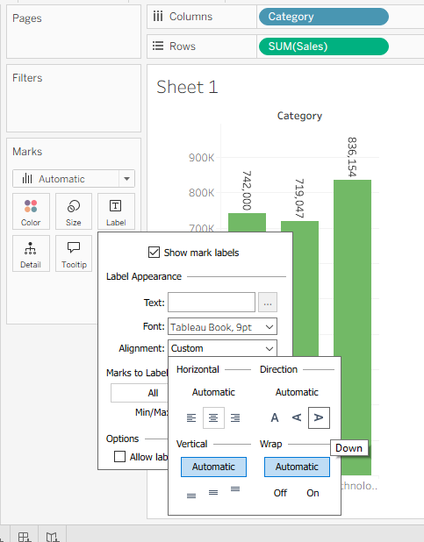
Tooltip
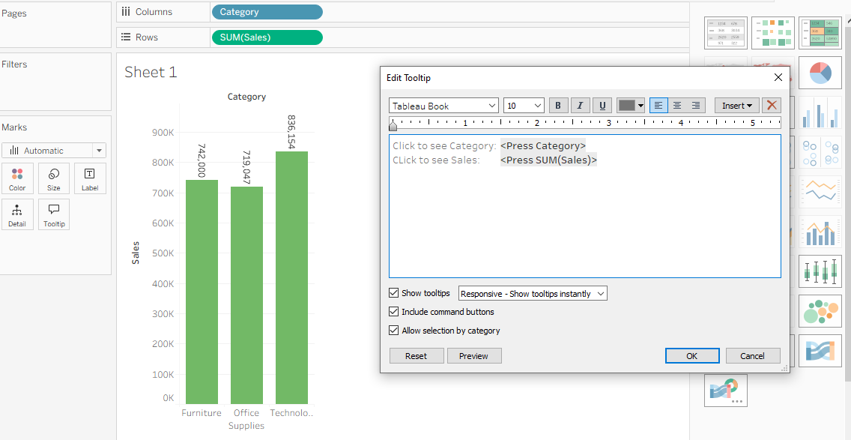
Output
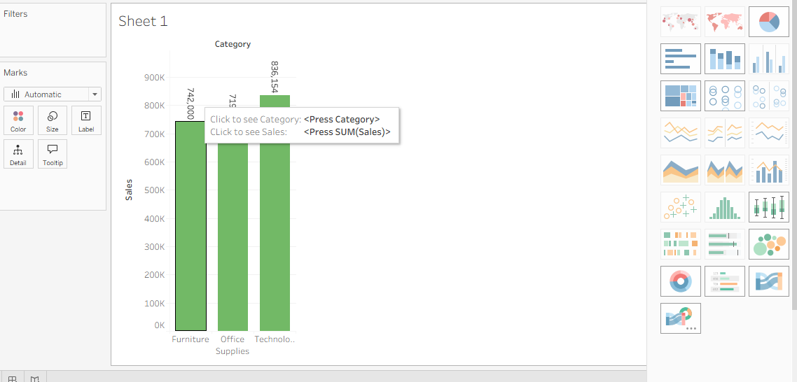
Change size

Add Filters
Drag:
Region
to
Filters
Suppose you select:
West
then Tableau shows:
Sales only for West Region.
If you select:
East
the chart changes automatically.
This makes the visualization interactive.
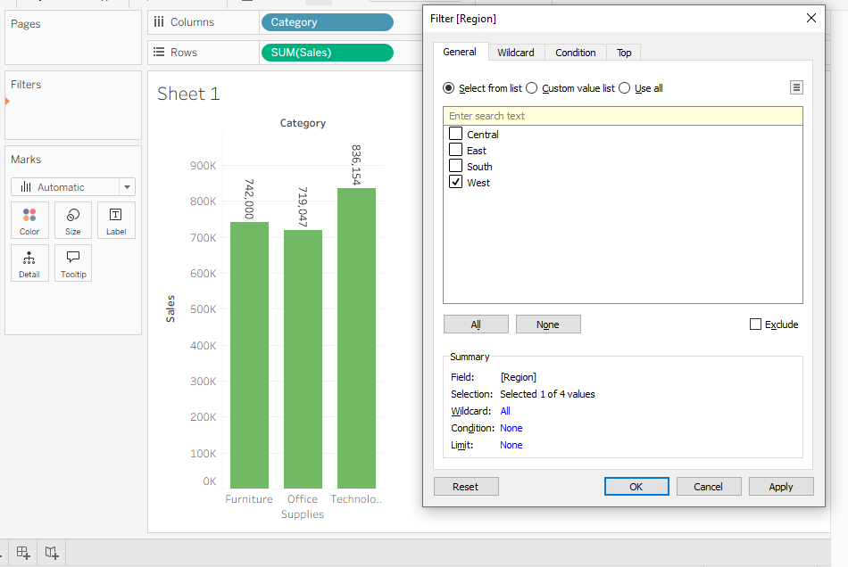
Output
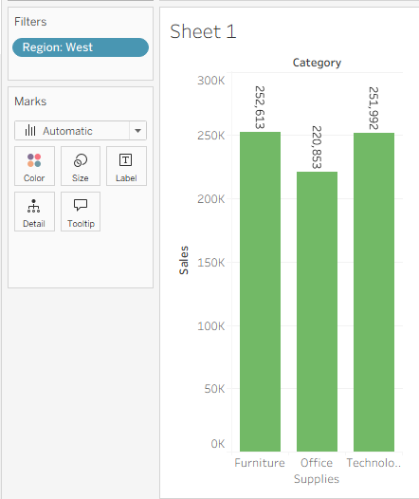
Using Show Me
Tableau also provides a feature called:
Show Me
located at the top-right corner.
Select:
Category
+
Sales
then click:
Show Me
↓

Bar Chart
Tableau will automatically generate the appropriate Bar Chart

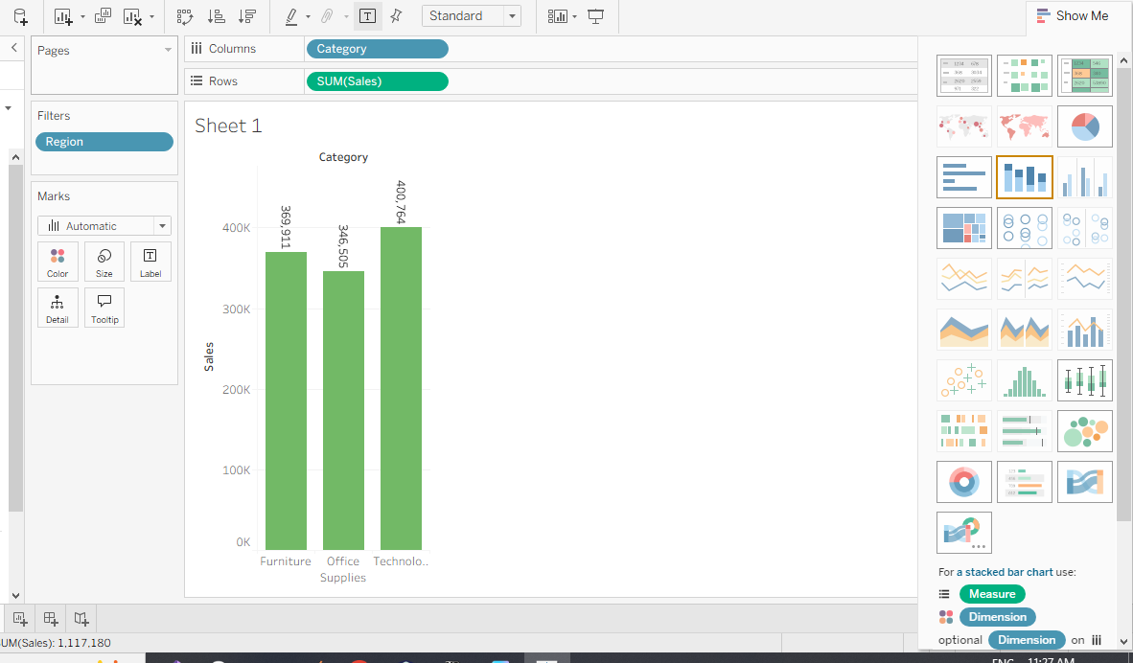
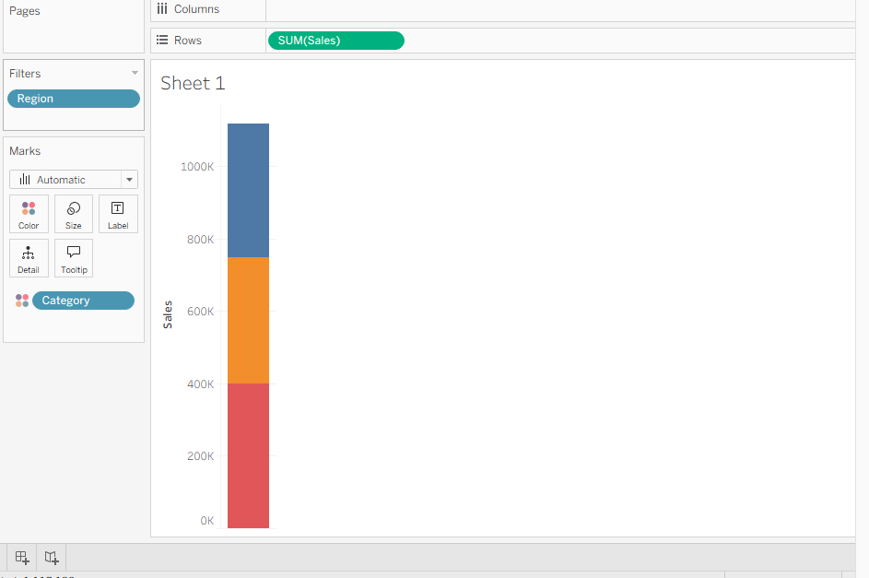
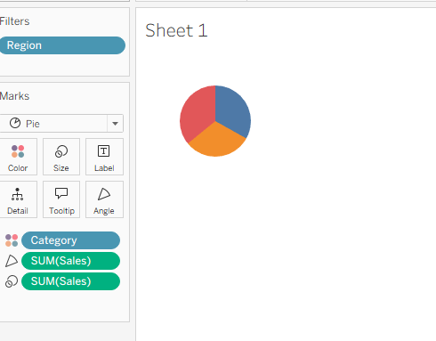
Build a Line Chart for Time-Series Analysis
Steps
- Drag Order Date to Columns.
- Select Month or Year.
- Drag Sales to Rows.
- Tableau creates a Line Chart automatically.
Analysis
You can observe:
- Monthly Sales
- Yearly Sales
- Sales Trends
- Growth Patterns

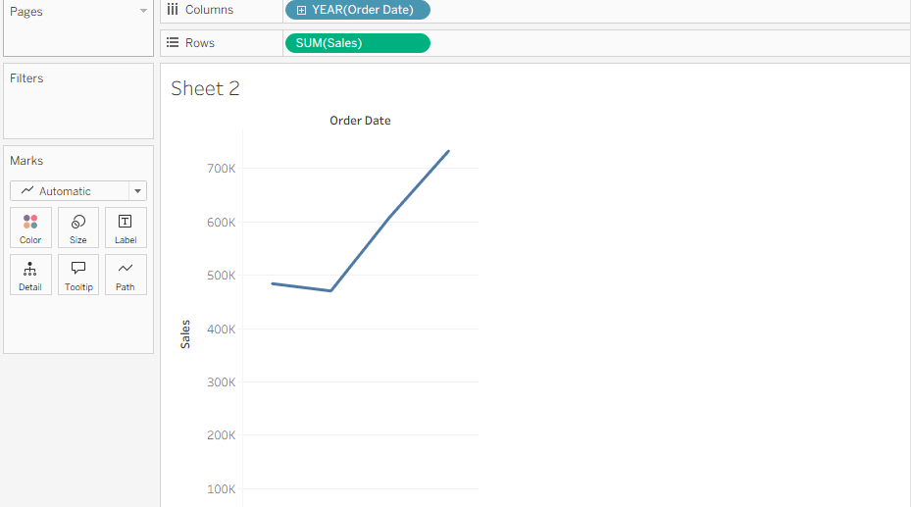
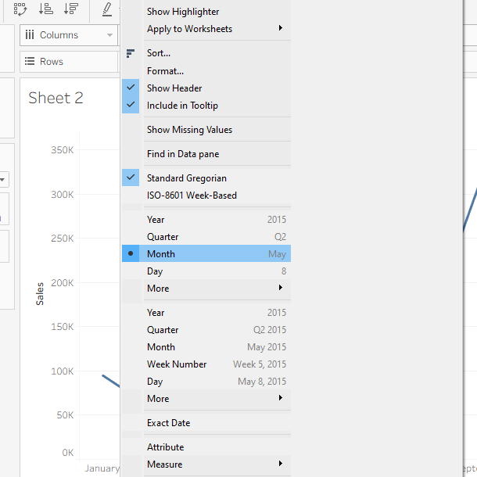
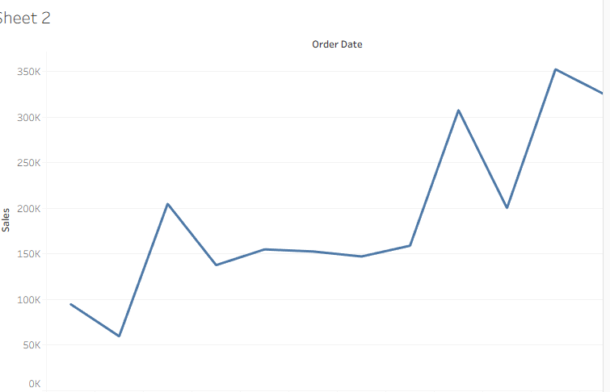

Create a Geographic Map Visualization
Steps
- Double click State.
- Tableau automatically recognizes geographical data.
- Drag Sales to Color.
- Drag Profit to Size.
- Apply filters if required.
Output
You can analyze:
- Highest Sales States
- Regional Performance
- Profit Distribution
Examples:
- Maharashtra
- Delhi
- Karnataka
- Gujarat
(if using Indian datasets)
or
- California
- Texas
- Florida
(if using Superstore dataset)
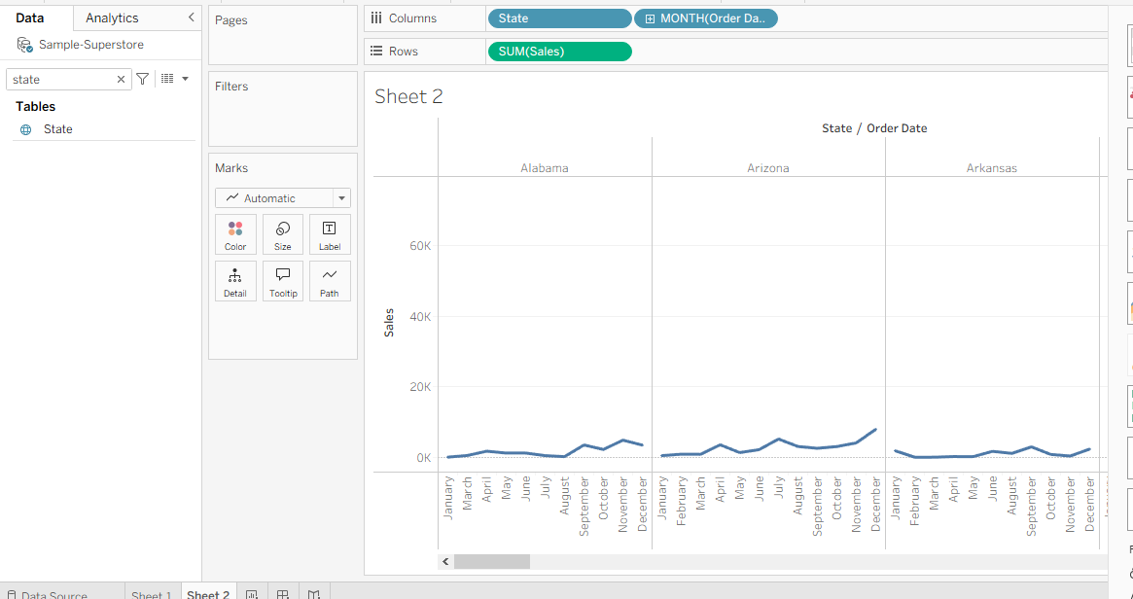
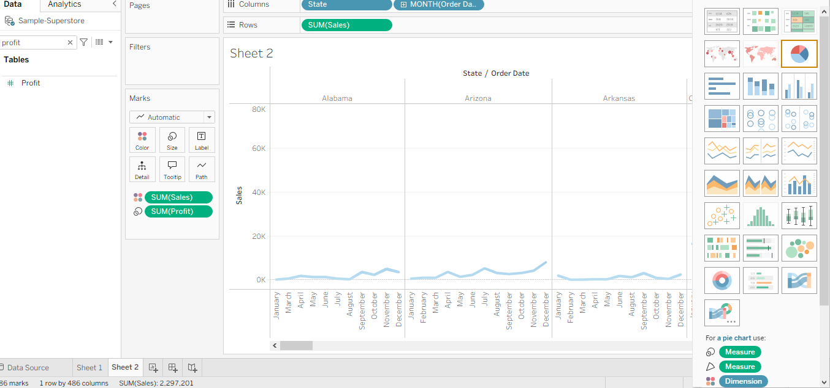
Combine Multiple Charts into an Interactive Dashboard
Steps
Create the following sheets:
- Bar Chart
  - Category vs Sales
- Line Chart
  - Monthly Sales
- Map Visualization
  - State wise Sales
- Pie Chart (optional)
  - Sales by Segment
Creating Dashboard
- Click Dashboard.
- Select New Dashboard.
- Drag all sheets into the dashboard.
- Arrange the layout.
- Add filters.
- Enable interactive actions.

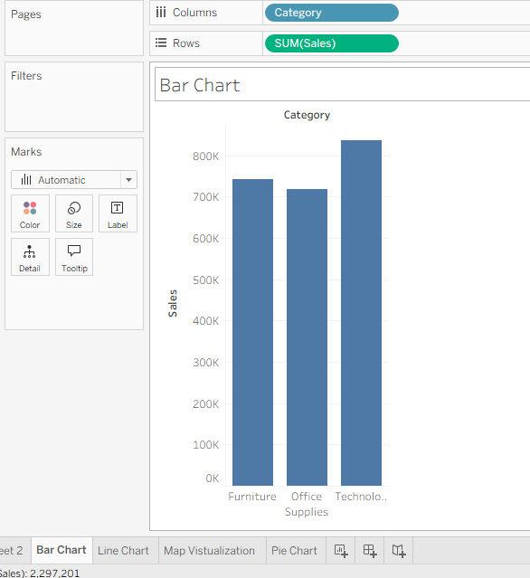
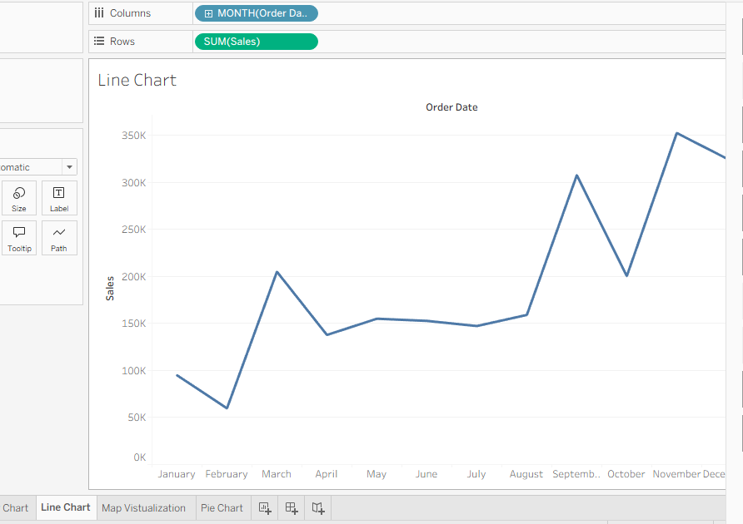
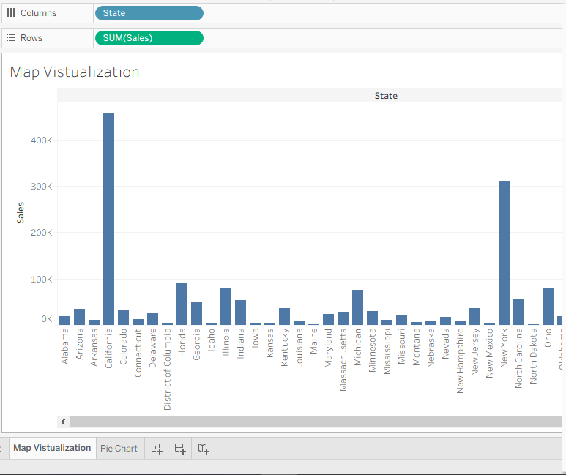
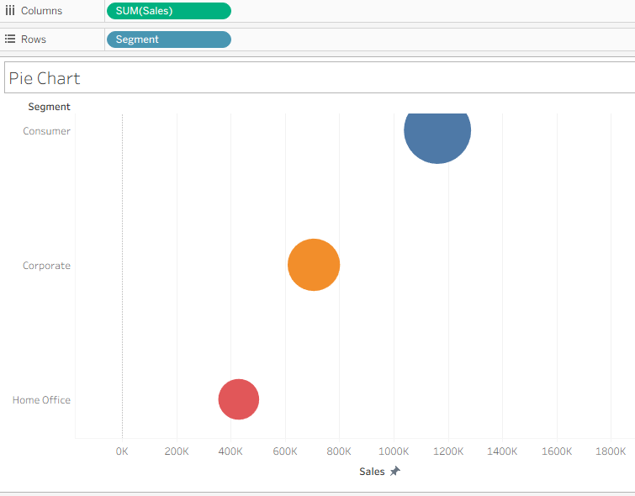
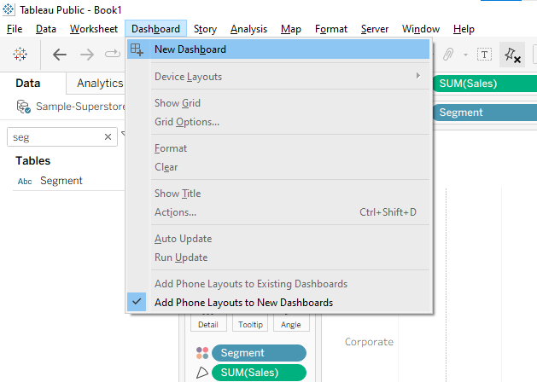

Final Dashboard
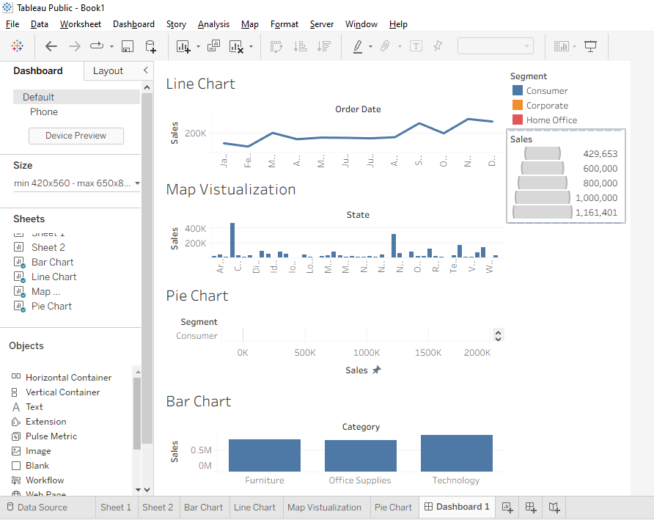

Practical 2
Field | Details
Name of Student | Mohammed Danish Firoz Shaikh
Roll No. of Student | 329
Semester | B.Sc (I.T) SEM-V
Academic Year | 2026-2027
Subject | Data Visualization with Power BI and Tableau
Faculty In-charge | Mr. Shahid Ansari
Practical No. | 2
Title | Practical 2: Working with Data Sources and Data Preparation in Tableau  a) Connect to different data sources (Excel, CSV, Database)  b) Create and use data extracts vs live connections  c) Manage metadata (rename, hide, change data types)  d) Perform joins (inner, left, right) on multiple tables  e) Apply data blending between two sources  f) Implement different types of filters (dimension, measure, date)  g) Optimize performance using extracts and filtering
Date

a) Connect to Different Data Sources
Tableau can connect to several types of data sources, including Excel, CSV, and databases.
1. Connect to Excel
- Open Tableau Desktop.
- Select Connect → Microsoft Excel.
- Select an Excel file, for example Sales.xlsx.
- Select the required worksheet.
- Click Sheet 1 to start visualization.
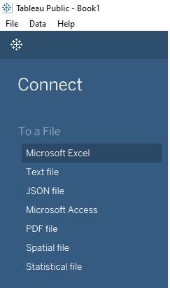
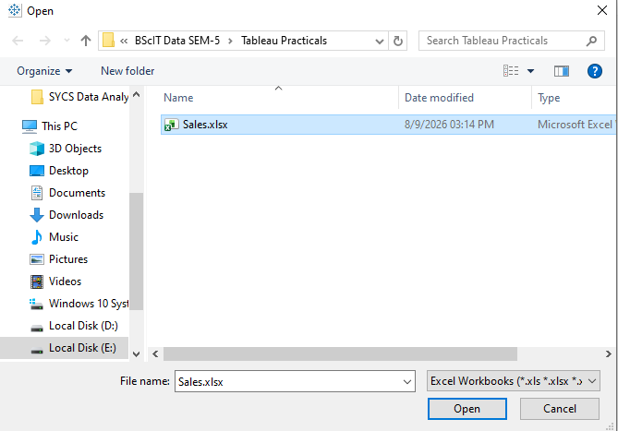
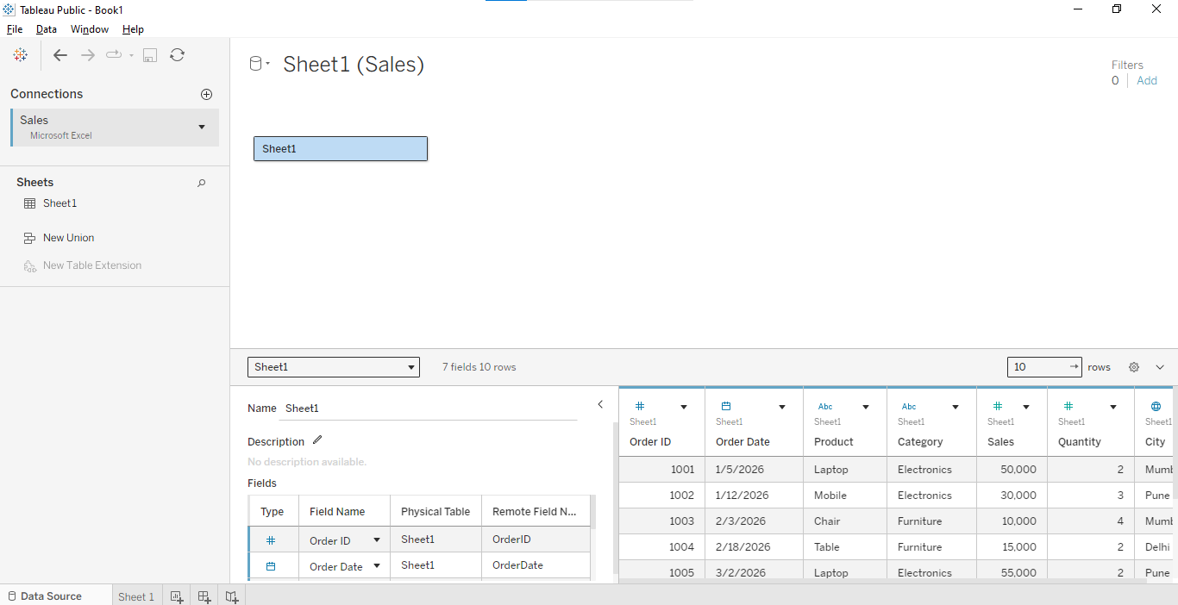
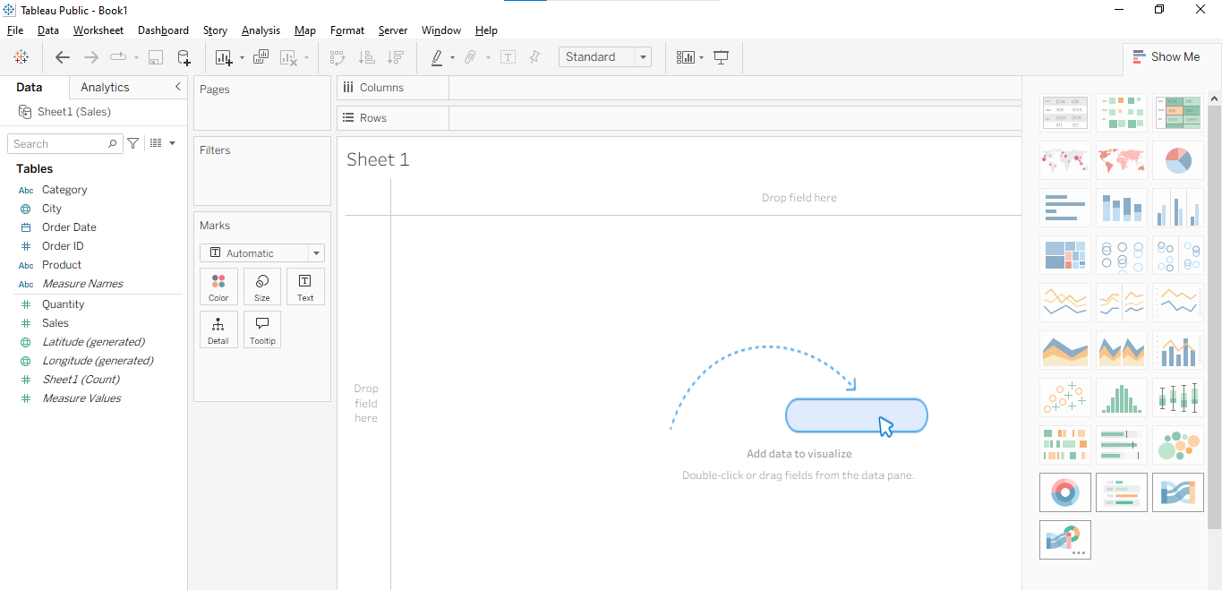
2. Connect to CSV
- Select Connect → Text File.
- Select Sales.csv.
- Tableau displays the CSV data.
- Click Sheet 1.
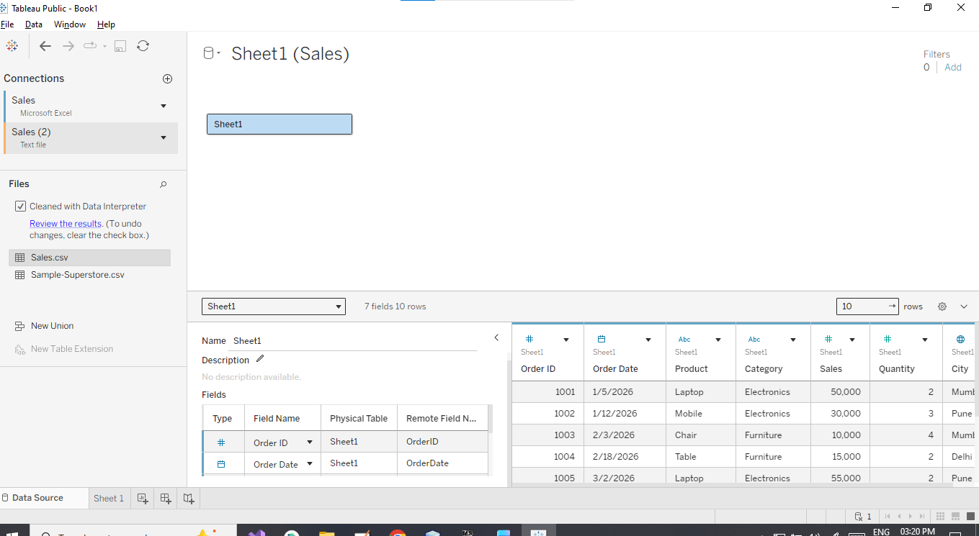

3. Connect to Database
For example, to connect to MySQL:
- Select Connect → MySQL.
- Enter:
  - Server
  - Username
  - Password
  - Database
- Click Sign In.
- Select the required table.
- Drag the table into the data model.

Create and Use Data Extracts vs Live Connections
Tableau provides two main ways to access data:
Live Connection
A live connection directly queries the original data source whenever Tableau needs data.
Advantages:
- Data is always up to date.
- No separate extract is required.
Disadvantages:
- Performance depends on the database.
- Large databases can be slower.
Extract Connection
An extract creates a snapshot of the data in Tableau's optimized extract format.
Steps to create an extract
- Connect to the data source.
- In the Data Source page, select Extract instead of Live.
- Click Sheet 1.
- Tableau creates an extract.
- You can refresh the extract when required.
Difference
Live Connection | Extract
Directly connects to source | Stores a copy of data
Data is generally current | Data updated during refresh
Can be slower | Usually faster
Requires source availability | Can work with extracted data

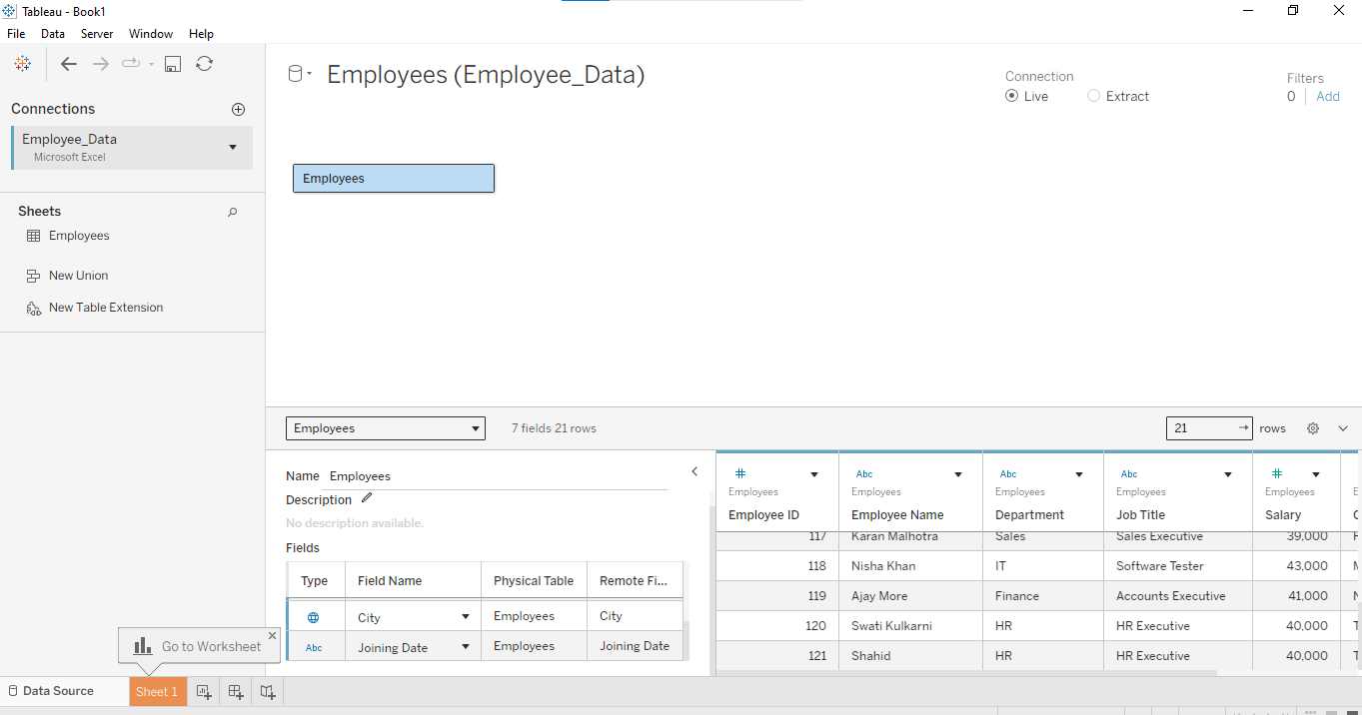
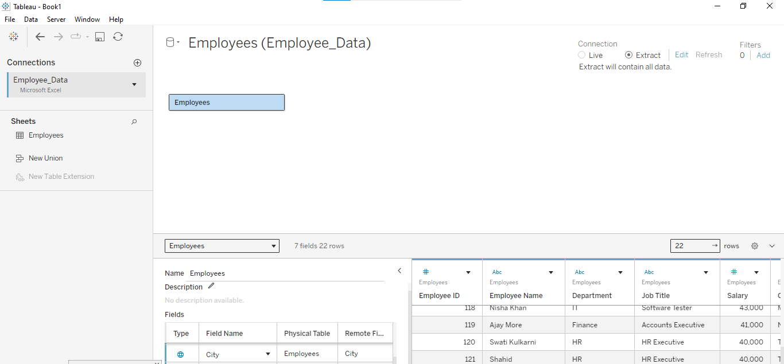

Manage metadata (rename, hide, change data types)
Metadata means information about the fields/columns in your Tableau data source. Tableau allows you to rename fields, hide fields, change data types, and organize fields without changing the original source data.
you can demonstrate these three operations:
- Rename a field
- Hide a field
- Change the data type

1. Rename a Field
Suppose your employee dataset contains:
emp_id | emp_name | dept | salary
101 | Rahul | IT | 45000
102 | Priya | HR | 50000
103 | Amit | Sales | 40000
You can rename:
emp_name → Employee Name
Steps
- Open Tableau.
- Connect to your dataset.
- Go to the Data Source page or the Data pane.
- Find the field you want to rename.
- Right-click the field.
- Select Rename.
- Enter the new name.
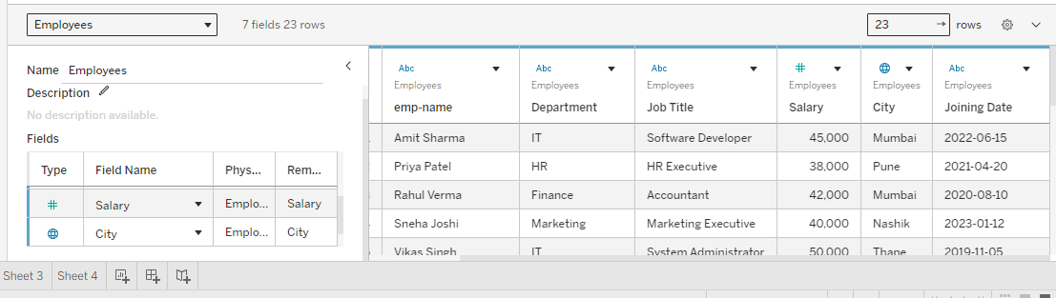
Hide a Field
Sometimes your dataset contains columns that you don't need for visualization.
For example:
Employee ID
Employee Name
Department
Salary
Phone Number
Address
If you don't want Phone Number to appear in Tableau's Data pane, you can hide it.
Steps
- Go to the Data pane.
- Find the field you want to hide.
- Right-click the field.
- Select Hide.
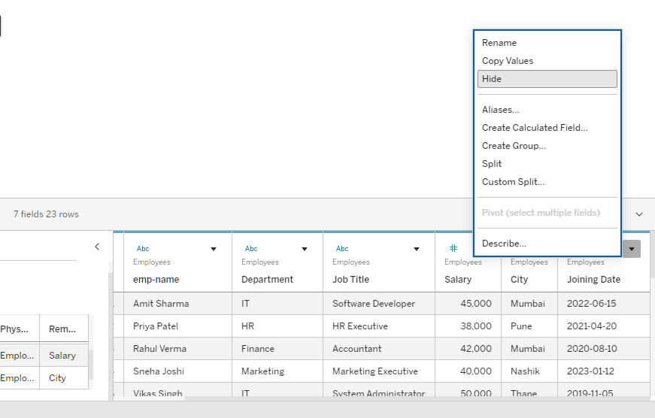
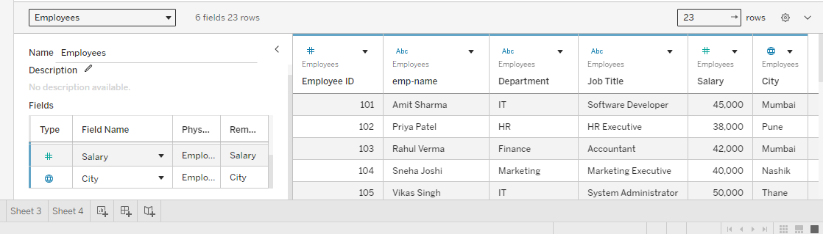
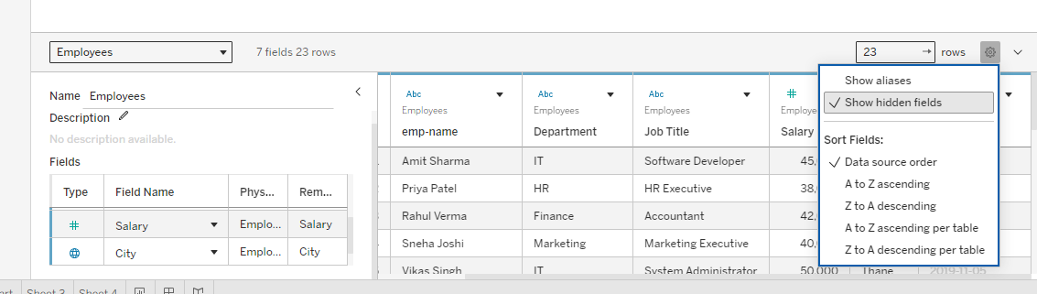

Change Data Type
A data type tells Tableau what kind of information a field contains.
Common Tableau data types include:
Data Type | Example
String | "Rahul"
Number (Whole) | 101
Number (Decimal) | 45000.50
Date | 12/08/2026
Date & Time | 12/08/2026 10:30 AM
Boolean | True / False
Tableau displays an icon next to the field indicating its data type.
Example: Change String to Number
Suppose Salary is incorrectly recognized as a string:
Steps
- Go to the Data pane.
- Find Salary.
- Click the data type icon next to the field.
- Select:
Number (Whole)
Now Tableau treats Salary as a numerical field.
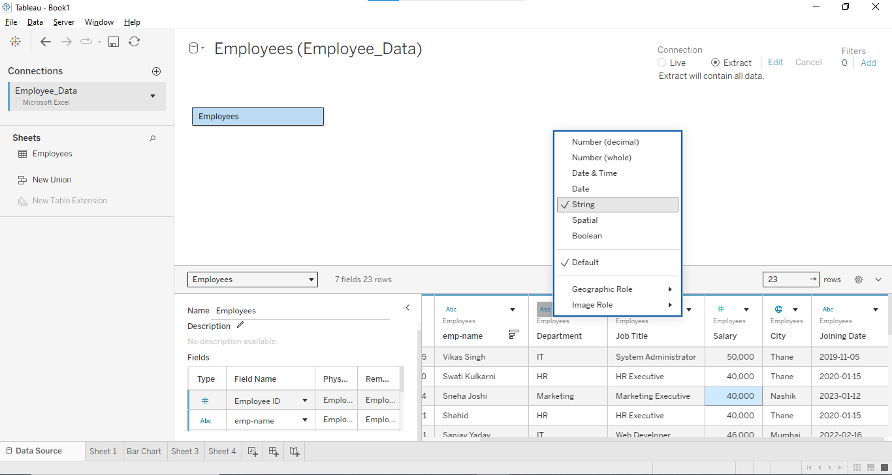
Practical Exercise

Objective: Connect Tableau to an Excel file and create a department-wise salary visualization.
Steps:
- Create an Excel file named Employee.xlsx.
- Add columns:
  - Employee_ID
  - Name
  - Department
  - Salary
  - Joining_Date
- Open Tableau.
- Connect to Employee.xlsx.
- Select the Employee worksheet.
- Check the data types.
- Open Sheet 1.
- Drag Department to Columns.
- Drag Salary to Rows.
- Change SUM(Salary) to Average if required.
- Select Bar Chart from Show Me.

Employee.csv
Employee_ID | Name | Department | Salary | Joining_Date
101 | Amit Sharma | IT | 45000 | 10-01-2022
102 | Neha Patel | HR | 40000 | 15-03-2022
103 | Rahul Verma | Sales | 50000 | 20-06-2021
104 | Priya Singh | Finance | 55000 | 05-02-2020
105 | Arjun Mehta | IT | 60000 | 18-07-2021
106 | Sneha Joshi | HR | 42000 | 25-09-2022
107 | Rohan Kumar | Sales | 48000 | 12-04-2023
108 | Pooja Shah | Finance | 58000 | 30-11-2020
109 | Karan Gupta | IT | 52000 | 08-01-2023
110 | Anjali Desai | Sales | 47000 | 22-05-2022

Perform Joins in Tableau
A join combines data from two or more tables using a common field. In Tableau, joins are performed in the Data Source page.
For a practical demonstration, we can use the following two tables.
Table 1: Employee
Employee_ID | Name | Department | Salary
101 | Amit Sharma | IT | 45000
102 | Neha Patel | HR | 40000
103 | Rahul Verma | Sales | 50000
104 | Priya Singh | Finance | 55000
105 | Arjun Mehta | IT | 60000
106 | Sneha Joshi | HR | 42000
107 | Rohan Kumar | Sales | 48000
108 | Pooja Shah | Finance | 58000
109 | Karan Gupta | IT | 52000
110 | Anjali Desai | Sales | 47000
Table 2: Employee_Project
Employee_ID | Project | Location
101 | Website Development | Mumbai
102 | Recruitment System | Pune
103 | Sales Dashboard | Mumbai
104 | Financial Analysis | Delhi
105 | Mobile Application | Mumbai
107 | CRM System | Pune
108 | Budget Analysis | Delhi
109 | Data Analytics | Mumbai
111 | Cloud Migration | Bangalore
Notice that Employee_ID 106 and 110 are present in the Employee table but not in Employee_Project, while Employee_ID 111 is present only in Employee_Project.
1. Inner Join
An Inner Join returns only records that have matching values in both tables.
Steps in Tableau
- Open Tableau Desktop.
- Connect to the Excel file containing the tables.
- Go to the Data Source page.
- Drag the Employee table into the workspace.
- Drag Employee_Project next to it.
- Tableau creates a join.
- Select the common field:
Employee.Employee_ID = Employee_Project.Employee_ID
- Select Inner Join.

2. Left Join
A Left Join returns:
- All records from the left table
- Matching records from the right table
- If there is no match, Tableau displays NULL
Suppose Employee is the left table.
3. Right Join
A Right Join returns:
- All records from the right table
- Matching records from the left table
- If there is no match, Tableau displays NULL
Difference Between Joins
Join | Records Returned
Inner Join | Matching records from both tables
Left Join | All records from left + matching records from right
Right Join | All records from right + matching records from left

Double-click Employee.csv
Look at the top-middle of your screen.
You should enter the Physical Layer
After double-clicking, the screen should change.
Drag Employee_Project.csv
Drag it from the left side into the main workspace.
Drop it next to Employee.csv.
Now the Join configuration should appear
This is the important part.
You should see a small join icon between the two tables.
Click that join icon.
You should get a menu containing:
Join Type

○ Inner
○ Left
○ Right
○ Full Outer
Select the common field
Tableau should automatically detect:
Employee.csv Employee_Project.csv
Employee ID = Employee ID

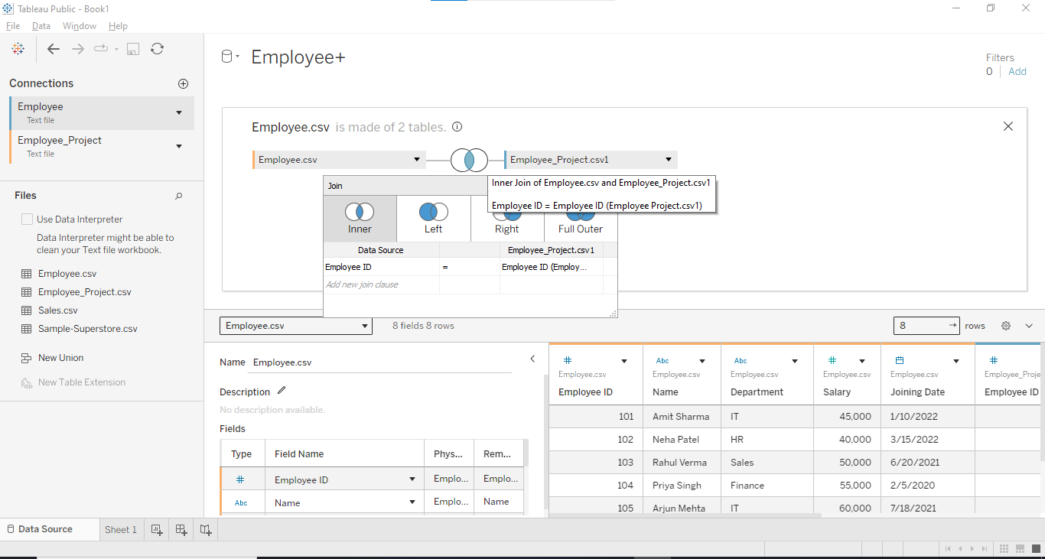
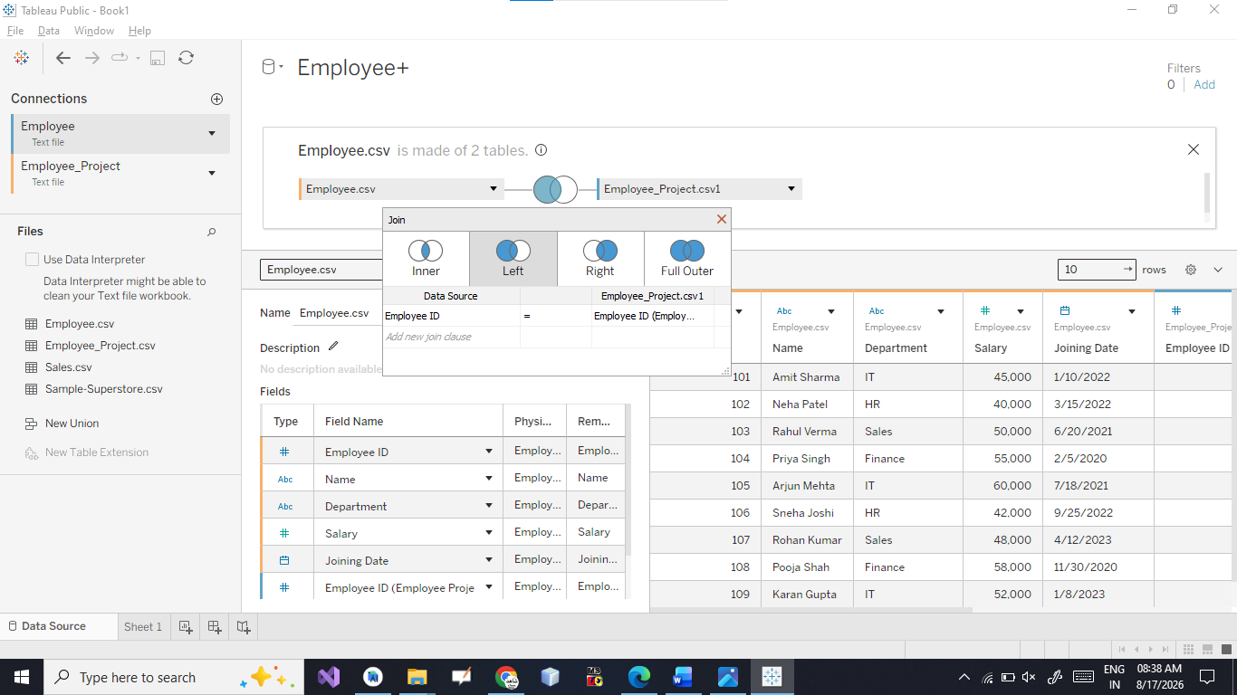
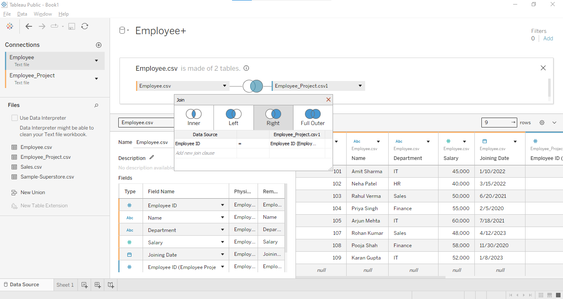
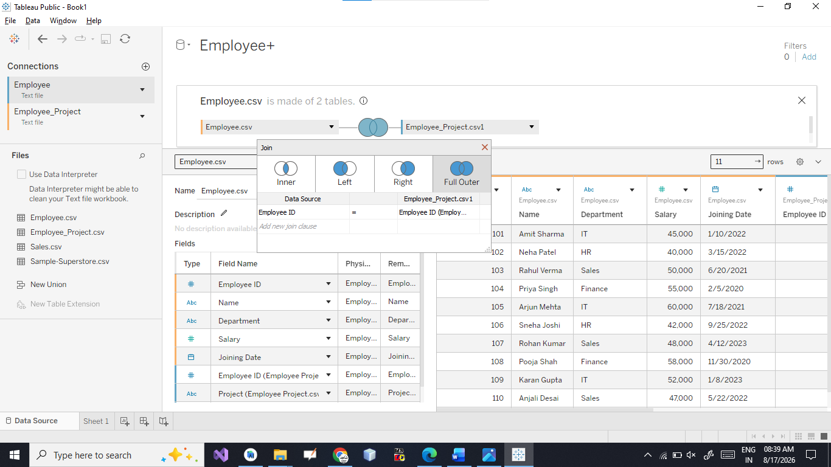

Apply Data Blending Between Two Sources in Tableau
Data Blending in Tableau is used to combine data from two different data sources in a single visualization.
For example, we can use:
- Source 1: Employee.csv → Employee details and Salary
- Source 2: Employee_Project.csv → Project details
- Common field: Employee_ID
Unlike a Join, the two sources remain separate and Tableau combines their data while creating the visualization.
Create a Worksheet
Click:
Sheet 1
Now use fields from Employee.csv.
For example:
- Drag Department → Columns
- Drag Salary → Rows
You will get a department-wise salary chart.
Add the Second Data Source
Now we need to add Employee_Project.csv.
Go to:
Data → New Data Source
Then select:
Text File → Employee_Project.csv
Now Tableau has two separate data sources.
You should see them in the Data pane on the left.
Something like:
DATA
Employee
└── Employee.csv
Employee_Project
└── Employee_Project.csv
Create the Data Blending Relationship
Go back to Sheet 1.
Make sure the primary source is:
Employee.csv
Now drag:
Department → Columns
and
Salary → Rows
The Employee.csv source will have a blue check mark indicating that it is the primary data source.
Add a Field from the Second Source
Now select Employee_Project.csv in the Data pane.
Drag:
Project
onto the visualization.
Tableau will try to find a common field between the two sources.
You should see a small link/chain icon next to Employee_ID.
The linking field is:
Employee_ID
Click the link icon if necessary to activate the relationship.

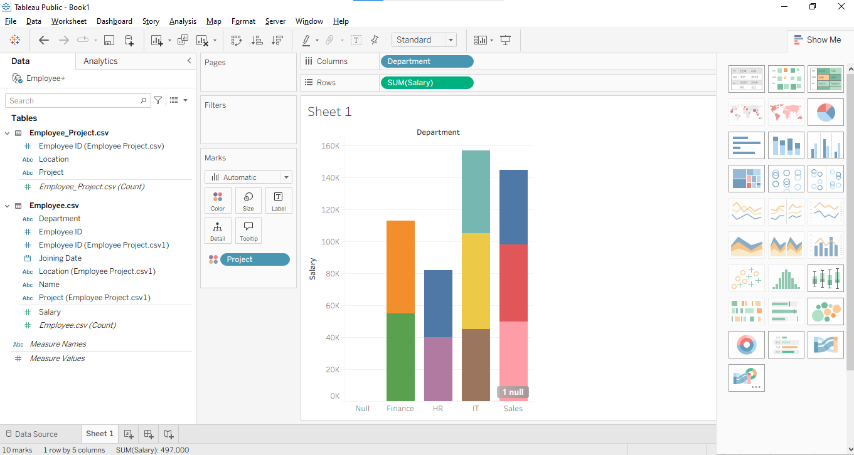

Implement Different Types of Filters in Tableau
Filters are used in Tableau to display only the required data. For example, we can filter employees based on Department, Salary, or Joining Date.
1. Dimension Filter
A dimension filter is used to filter categorical fields such as:
- Department
- Name
- Location
- Project
Example: Filter by Department
Step 1
Open Sheet 1.
Step 2
Drag:
Department → Columns
Step 3
Drag:
Salary → Rows
You will get a department-wise salary chart.
Step 4
Drag Department again from the Data pane to the Filters shelf.
A window will appear:
Filter [Department]
☑ IT
☑ HR
☑ Sales
☑ Finance
OK
Step 5
Select only:
IT
Click OK.
Now the visualization displays only IT employees.

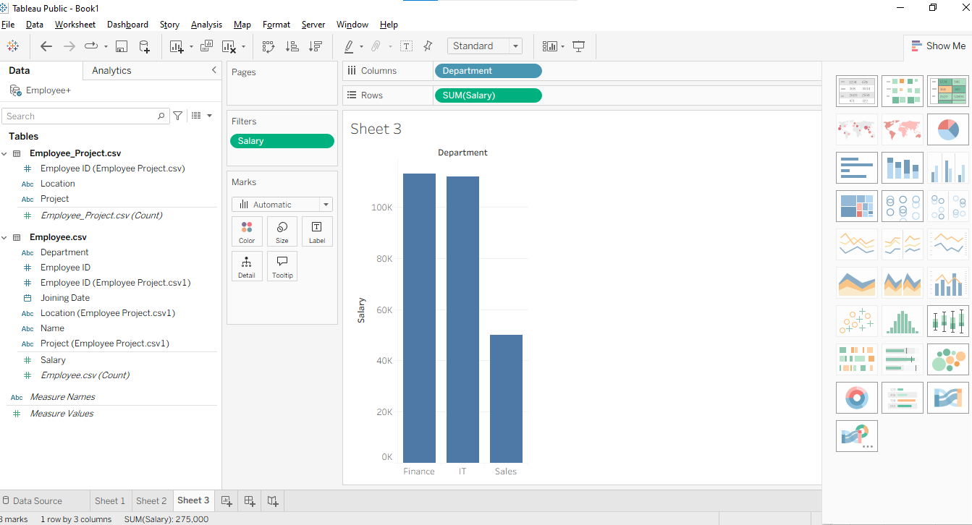
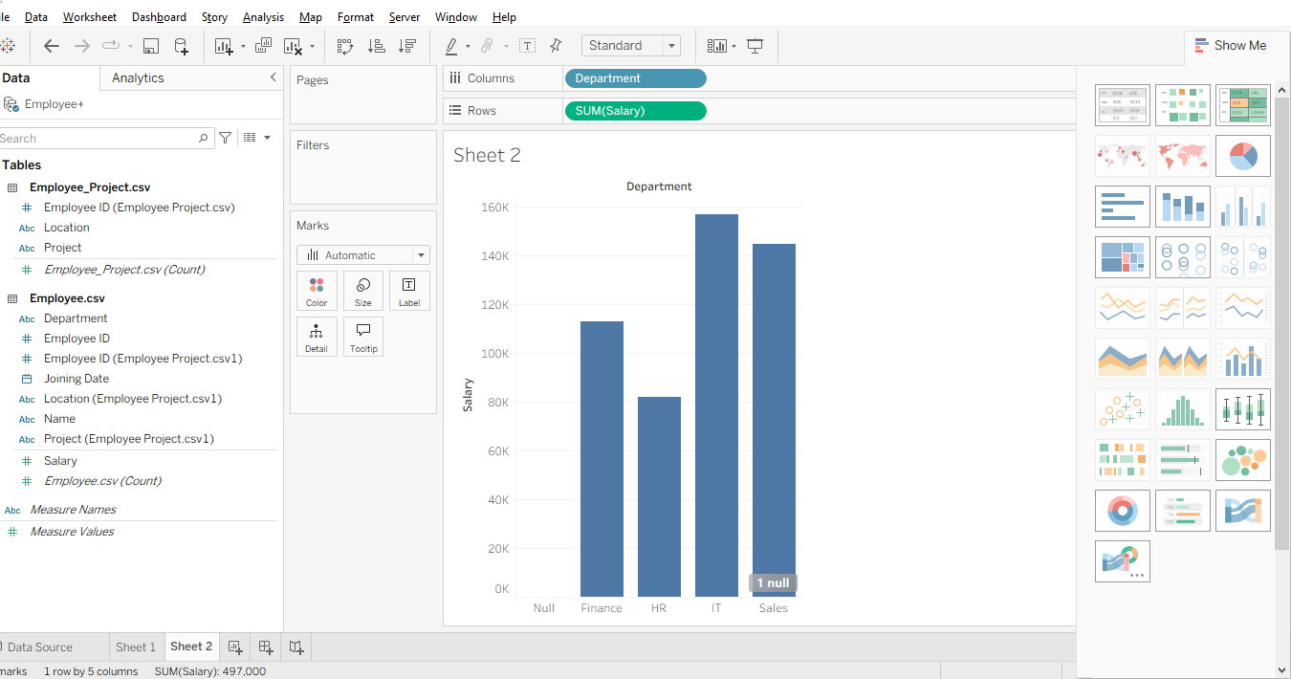
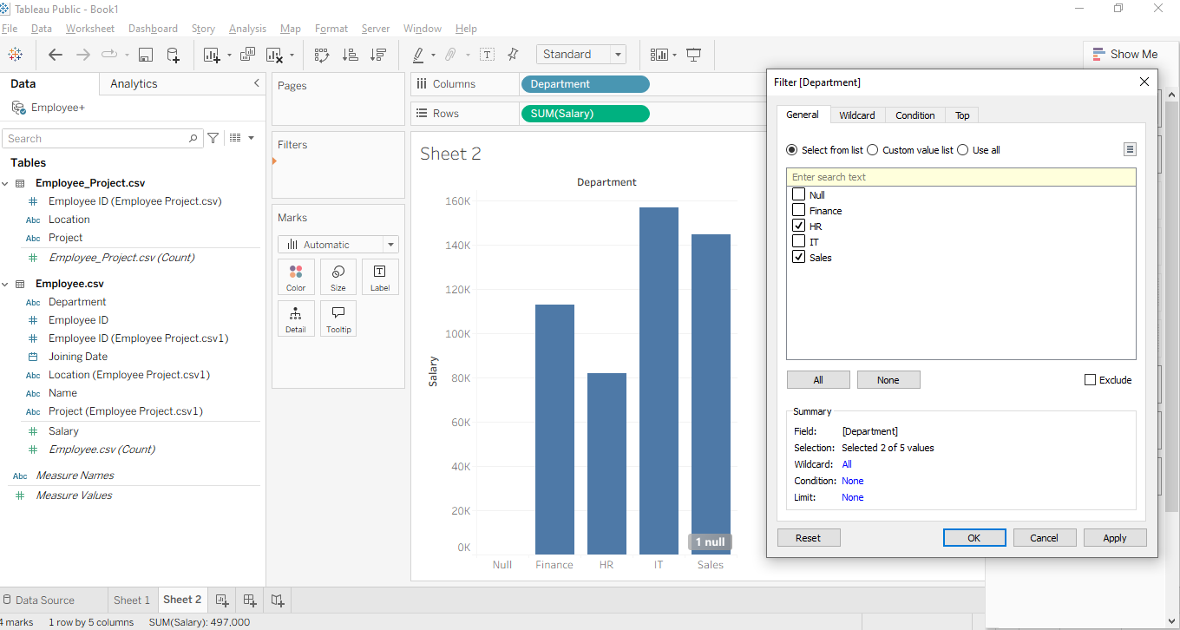

Measure Filter
A measure filter is used to filter numerical values such as:
- Salary
- Sales
- Quantity
- Profit
Example: Salary greater than ₹50,000
Step 1
Create a visualization:
Department → Columns
Salary → Rows
Step 2
Drag Salary from the Data pane to the Filters shelf.
A window will appear.
You will see options such as:
Filter Field [Salary]
Range of values
At least
At most
Special
Select:
At least
Enter:
50000
Click OK.
Now Tableau will display records where Salary is ₹50,000 or more.
Employees satisfying the condition
Employee | Department | Salary
Rahul Verma | Sales | 50000
Priya Singh | Finance | 55000
Arjun Mehta | IT | 60000
Pooja Shah | Finance | 58000
Karan Gupta | IT | 52000

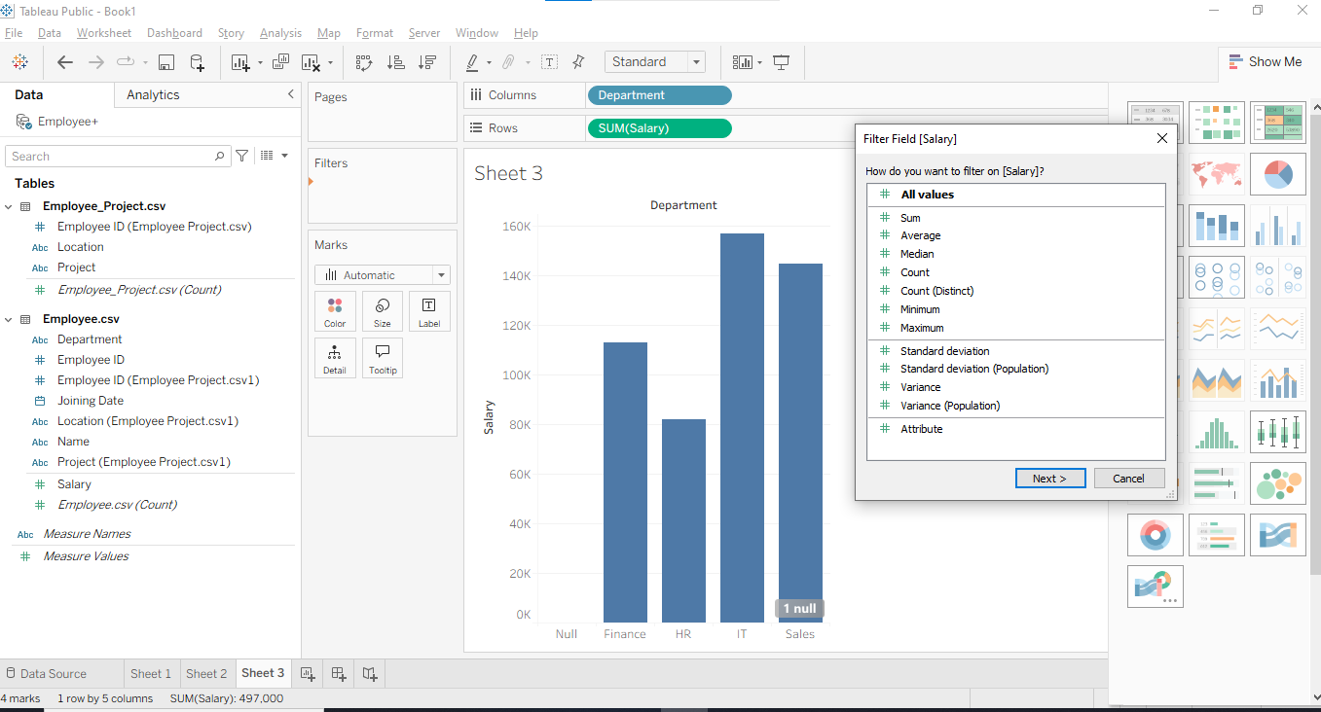
Click Next
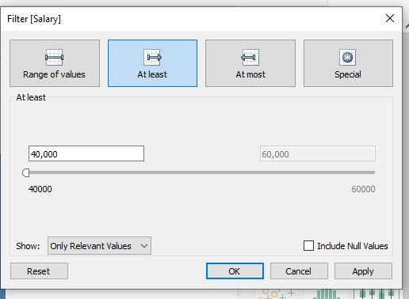
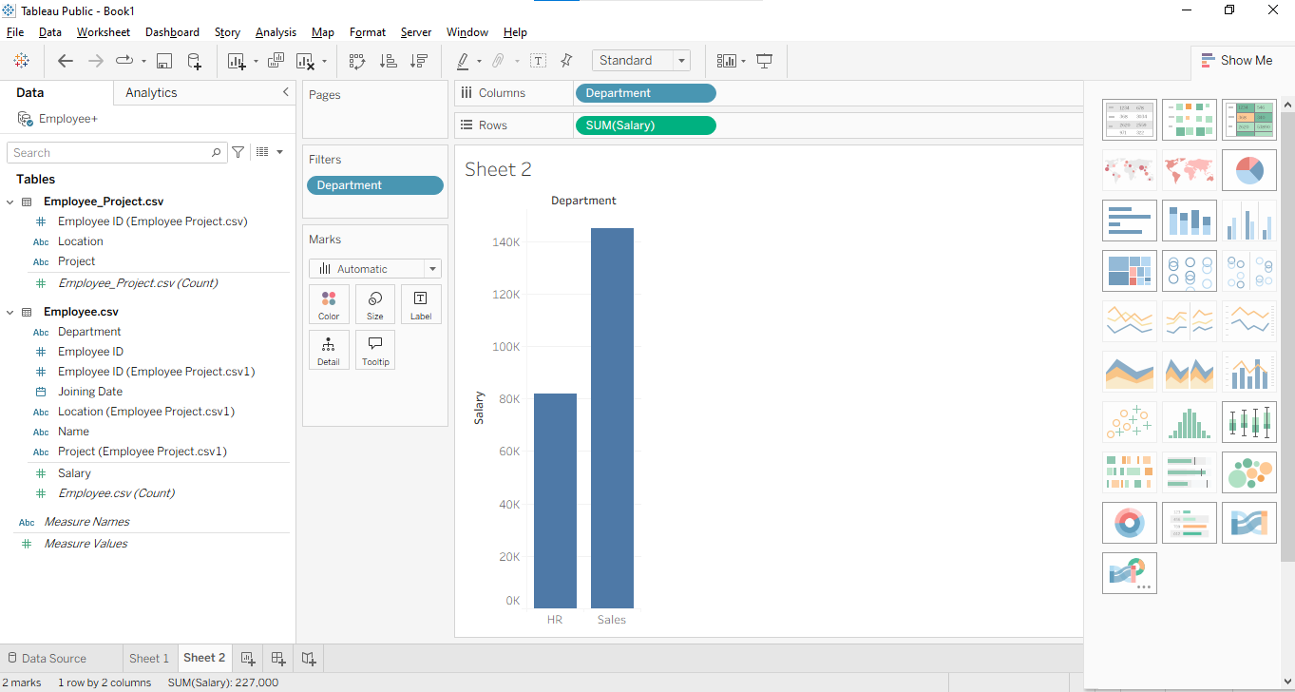
Optimize Performance Using Extracts and Filtering in Tableau
When working with large datasets, Tableau visualizations may become slow. Two useful techniques for improving performance are:
- Using Extracts
- Applying Filters effectively

1. Using Extracts
An Extract is a snapshot of data that Tableau stores in its optimized data engine.
Instead of querying the original data source every time a visualization is opened, Tableau can work with the extract.
Live Connection vs Extract
Live Connection | Extract
Queries the original data source | Uses a stored copy of the data
May be slower for large data | Usually faster for analysis
Data is more current | Data is refreshed when required
Depends on the original source | Can work from the extract

Simple Example
Suppose you have a CSV file containing:
1,000,000 employee/sales records
With a live connection, Tableau may repeatedly read/query the source.
With an extract:
Large Data Source
↓
Extract
↓
Tableau Visualization
Tableau can work with the optimized extract.
Creating an Extract in Tableau
Using your current Employee.csv example:
Step 1
Open your Tableau workbook.
Go to:
Data Source
You will see your data connection.
Step 2
Look for the connection option:
Live | Extract
Select:
Extract
Depending on your Tableau Public/version interface, Tableau may show an Extract option rather than the Live/Extract buttons directly.
Step 3
If available, click:
Edit
or Extract settings.
You can configure how much data should be stored.
Step 4
Click:
Extract
or save the workbook when prompted.
Tableau creates an optimized extract of the data.

